Newsletter March 2020
Dear Parents and Carers
The children are loving their wonderful garden and mud kitchen and have been spending lots of time exploring and playing outside. Woodland walks have been very popular, we have enjoyed exploring the great outside, reading stories and having snack in the woods. Don’t forget to make sure your child has suitable clothing and footwear for outside play.
Recent topics that we have been exploring have been, Police and emergency services and Space and transport; the children have enjoyed making moon stones, UFO’S and intergalactic passports! We shared the love on Valentines day and enjoyed a tea party and then delivered Valentines cards and balloons to Coombe house.
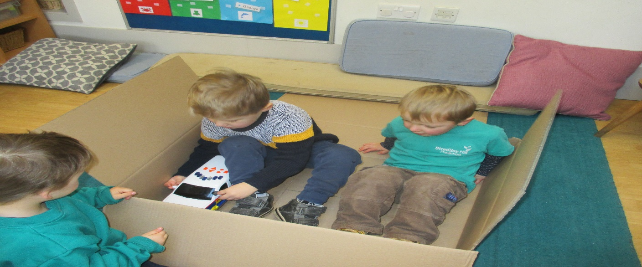
Please let your child’s key person know what your child has been doing at home, we can add their interests into the planning and it is lovely to share achievements and hobbies in their learning journeys. We have a sheet you can use or make your own! There is a parent helper rota on the front door, please sign up, we would love to fill up as many spaces as possible and it’s a great way to support preschool. Please continue to send in healthy snacks, we are very grateful for all contributions. Breadsticks, bread, cheese, fresh fruit and vegetables are always popular.
Could I remind parents not to include nuts or peanuts in lunchboxes please, we have allergies at Pre School and must be strict on this. You are welcome to send in a cake etc to celebrate your child’s birthday. Don’t forget it needs to be nut and traces of nut free.
Please regularly check your child’s hair for headlice. Please see https://www.nhs.uk/conditions/head-lice-and-nits/ Many thanks.
Please see Gov.uk for latest updates and advice on the Coronavirus. We will continue to use hand gel at the preschool door.
Polite reminder, please ensure you or the nominated person collecting your child is on time at the end of their session, this ensures our ratios are correct and allows preschool to follow our health and safety requirements. If you are going to be late please call preschool to inform staff. Thank you.
Streatley Hill Pre School is part of ECAT ‘Every child’s a talker’ It is a national strategy to promote the support of language development and communication skills. Please look on our notice board for talking tips or speak to Lisa for further information. http://westberksecat.info/
Staff can also offer advice and information about speech and language drop-in sessions, if you have any concerns about your child’s language development.
Safeguarding is everyone’s responsibility, please see myself or any member of staff if you have any concerns. There is a safeguarding board by the front desk which has phone numbers to report concerns. If I could remind parents that there is a strict no mobile phones policy in preschool, this is an Ofsted requirement to safeguard children in all Early year’s settings.
Have you heard of EYPP? This stands for Early Years pupil premium and it is extra money that Pre School could claim to benefit your child and the setting, if parents receive certain benefits or are on a low income. Please speak to me in confidence if you believe you may be eligible.
I would absolutely love to have some new story sacks at preschool, please see me if you could help to put one together!!!
Dates for your diary
World book day | Thursday  05/03/2020 | Dress up day!!!!!!!!!
Visit to Coombe house | 03/04/2020  @10.45am | For the children attending this session.
Easter Holidays | Monday  06/04/2020  (Preschool opens 20/04/2020) | Pre School closed.
Parents evening | Tuesday  21/04/2020  @6-8pm | At Pre School. More information to follow

Thank you for your continued support, we couldn’t do what we do without the wonderful support from our committee and parents.
Kind regards
Cheryl

